|  |
| --- |
| **Department of**  **Computer Science and Engineering** |
| **Assignment**   Course No: CSE-210Course Title: Object Oriented ProgrammingSubmitted By:NAME : Kamelia Zaman MoonROLL NO : 299SESSION : 2017-18DATE SUBMITTED : 31.03.2019Submitted To:Dr. Md. Ezharul IslamAssociate ProfessorDepartment of Computer Science & Engineering,Jahangirnagar University |

**Chapter-02**

**Problem No.-02**

**Code:**

#include<iostream>

using namespace std;

int main()

{

cout<<1990<<"\t\t\t"<<135<<endl<<1991<<"\t\t\t"<<7290<<endl<<1992<<"\t\t\t"<<11300<<endl<<1993<<"\t\t\t"<<16200<<endl;

return 0;

}

**Output:**

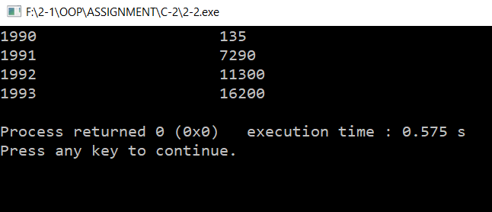

**Problem No.-04**

**Code:**

#include<iostream>

#include<iomanip>

using namespace std;

int main()

{

cout<<"Candy is dandy,\nBut liquor is quicker."<<endl;

return 0;

}

**Output:**

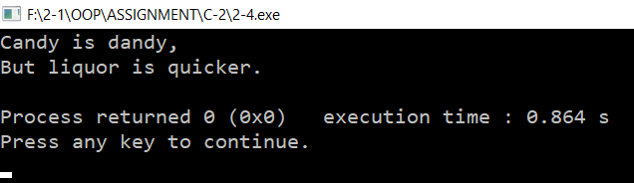

**Problem No.-06**

**Code:**

#include<iostream>

#include<iomanip>

using namespace std;

int main()

{

double n,P=1.487,F=0.172,D=0.584,Y=0.00955;

cout<<"Enter the amount in dollars: ";

cin>>n;

cout<<"In Pound: "<<P*n<<"\nIn Franc: "<<F*n<<"\nIn Deutschemark: "<<D*n<<"\nIn Yen: "<<Y*n<<endl;

return 0;

}

**Output:**

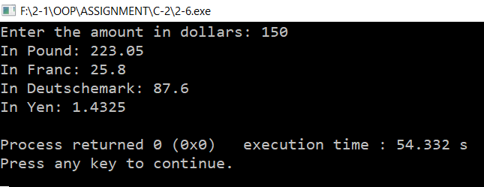

**Problem No.-08**

**Code:**

#include <iostream>

#include <iomanip>

using namespace std;

int main()

{ cout<<setfill('.')<<setw(8)<<"LOCATION"<<setw(20)<<"POPULATION"<<endl<<setw(8)<<"portcity"<<setw(20)<<"2425785"<<endl<<setw(8)<<"Hightown"<<setw(20)<<"47"<<endl<<setw(8)<<"Hightown"<<setw(20)<<"9761"<<endl;

return 0;

}

**Output:**

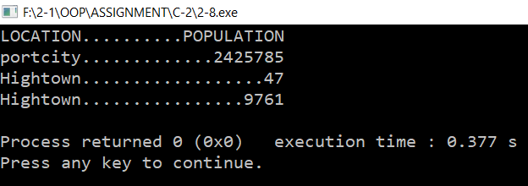

**Problem No.-10**

**Code:**

#include<iostream>

#include<iomanip>

using namespace std;

int main()

{

double p,s,pn;

cout<<"Enter pounds: ";

cin>>p;

cout<<"Enter shillings: ";

cin>>s;

cout<<"Enter pence: ";

cin>>pn;

cout<<"Decimal pounds = \x9c"<<p+((s+(pn/12))/20)<<endl;

return 0;

}

**Output:**

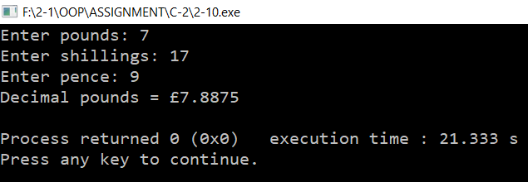

**Problem No.-12**

**Code:**

#include<iostream>

#include<iomanip>

using namespace std;

int main()

{

double deci,deci1,deci2;

cout<<"Enter decimal pounds: ";

cin>>deci;

int p,s,pn;

p=static_cast<int>(deci);

deci1=(deci-p)*20;

s=static_cast<int>(deci1);

deci2=(deci1-s)*12;

pn=static_cast<int>(deci2);

cout<<"Equivalent in old notation = \x9c"<<p<<"."<<s<<"."<<pn<<"."<<endl;

return 0;

}

**Output:**

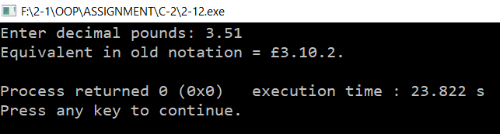

**Chapter-03**

**Problem No.-02**

**Code:**

#include<iostream>

#include<iomanip>

using namespace std;

int main()

{

double c,f,t;

cout<<"Type 1 to convert Fahrenheit to Celsius,\n 2 to convert Celsius to Fahrenheit: ";

cin>>t;

if(t==1)

{

cout<<"Enter temperature in Fahrenheit: ";

cin>>f;

cout<<"In Celsius that's "<<((f-32)/9)*5<<endl;

}

else if(t==2)

{

cout<<"Enter temperature in Celsius: ";

cin>>c;

cout<<"In Fahrenheit that's "<<((c/5)*9)+32<<endl;

}

return 0;

}

**Output:**

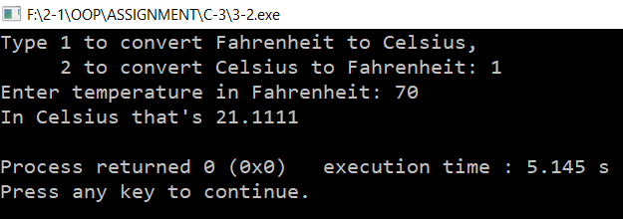

**Problem No.-04**

**Code:**

#include<iostream>

#include<iomanip>

using namespace std;

int main()

{

float a,b;

char ch,t;

cout<<"Enter first number, operator, second number: ";

while(cin>>a>>ch>>b)

{

switch(ch)

{

case '+':

cout<<"Answer = "<<a+b<<endl;

break;

case '-':

cout<<"Answer = "<<a-b<<endl;

break;

case '*':

cout<<"Answer = "<<a*b<<endl;

break;

case '/':

cout<<"Answer = "<<a/b<<endl;

break;

}

cout<<"Do another (y/n)? ";

cin>>t;

switch(t)

{

case 'y':

cout<<"Enter first number, operator, second number: ";

continue;

break;

case 'n':

return 0;

break;

}

}

return 0;

}

**Output:**

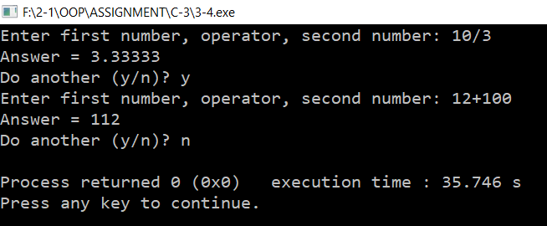

**Problem No.-06**

**Code:**

#include<iostream>

#include<iomanip>

using namespace std;

int main()

{

long long int n,fact,i;

cout<<"Enter a number: ";

while(cin>>n && n!=0)

{

fact=1;

for(i=n;i>0;i--)

fact=fact*i;

cout<<"Factorial is "<<fact<<endl;

cout<<"Enter a number: ";

}

return 0;

}

**Output:**

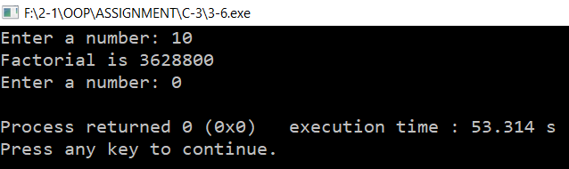

**Problem No.-08**

**Code:**

#include<iostream>

#include<iomanip>

using namespace std;

int main()

{

int p1,p2,s1,s2,pn1,pn2;

char a1,b1,c1,a2,b2,c2,t;

cout<<"Enter first amount: ";

while(cin>>a1>>p1>>b1>>s1>>c1>>pn1)

{

cout<<"Enter second amount: ";

cin>>a2>>p2>>b2>>s2>>c2>>pn2;

cout<<"Total is \x9c"<<p1+p2+((s1+s2+((pn1+pn2)/12))/20)<<"."<<(s1+s2+((pn1+pn2)/12))%20<<"."<<(pn1+pn2)%12<<endl;

cout<<"Do you wish to continue (y/n)? ";

cin>>t;

switch(t)

{

case 'y':

cout<<"Enter first amount: ";

continue;

break;

case 'n':

return 0;

break;

}

}

return 0;

}

**Output:**

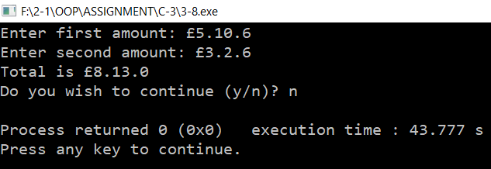

**Problem No.-10**

**Code:**

#include<iostream>

#include<iomanip>

using namespace std;

int main()

{

float P,r,C,t;

int n=0;

cout<<"Enter initial amount: ";

cin>>P;

cout<<"Enter interest rate (percent per year): ";

cin>>r;

cout<<"Enter final amount: ";

cin>>C;

r=1+(r/100);

t=P;

while(t<C)

{

t*=r;

n++;

}

cout<<"Year: "<<n<<endl;

return 0;

}

**Output:**

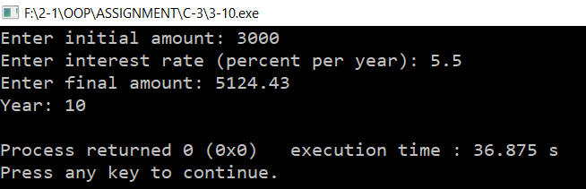

**Problem No.-12**

**Code:**

#include<iostream>

#include<iomanip>

using namespace std;

int main()

{

float a,b,c,d;

char t;

cout<<"Enter the first fraction: ";

cin>>a>>b;

cout<<"Enter an operator(+, -, *, /): ";

cin>>t;

cout<<"Enter the second fraction: ";

cin>>c>>d;

switch(t)

{

case '+':

cout<<"Addition: "<<a<<"/"<<b<<" + "<<c<<"/"<<d <<" = "<<((a*d+b*c)/(b*d))<<endl;

break;

case '-':

cout<<"Subtraction: "<<a<<"/"<<b<<" - "<<c<<"/"<<d <<" = "<<((a*d-b*c)/(b*d))<<endl;

break;

case '*':

cout<<"Multiplication: "<<a<<"/"<<b<<" * "<<c<<"/"<<d<<" = "<<((a*c)/(b*d))<<endl;

break;

case '/':

cout<<"Division: "<<a<<"/"<<b<<" / "<<c<<"/"<<d <<" = "<<((a*d)/(b*c))<<endl;

break;

}

return 0;

}

**Output:**

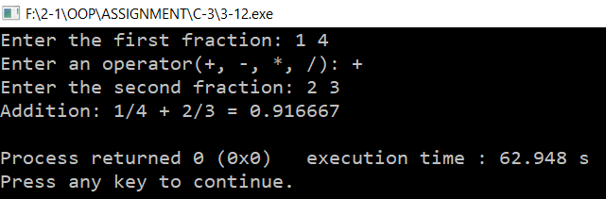

**Chapter-04**

**Problem No.-02**

**Code:**

#include<iostream>

#include<iomanip>

using namespace std;

struct Point

{

int x,y;

};

int main()

{

Point p1,p2,xx,yy;

cout<<"Enter coordinates for p1: ";

cin>>p1.x>>p1.y;

cout<<"Enter coordinates for p2: ";

cin>>p2.x>>p2.y;

cout<<"Coordinates of p1+p2 are: "<<p1.x+p2.x<<", "<<p1.y+p2.y<<endl;

return 0;

}

**Output:**

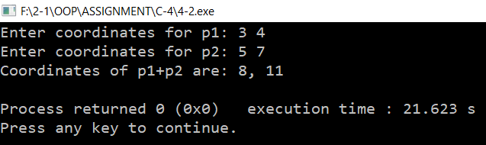

**Problem No.-04**

**Code:**

#include<iostream>

#include<iomanip>

using namespace std;

struct employee

{

int number;

float compensation;

};

int main()

{

employee e1,e2,e3;

cout<<"Enter first employee number and the employee's compensation: ";

cin>>e1.number>>e1.compensation;

cout<<"Enter second employee number and the employee's compensation: ";

cin>>e2.number>>e2.compensation;

cout<<"Enter third employee number and the employee's compensation: ";

cin>>e3.number>>e3.compensation;

cout<<"\tEmployee number:\tEmployee's compensation:\n\t"<<e1.number<<"\t\t\t"<<e1.compensation<<endl<<"\t"<<e2.number<<"\t\t\t"<<e2.compensation<<endl<<"\t"<<e3.number<<"\t\t\t"<<e3.compensation<<endl;

return 0;

}

**Output:**

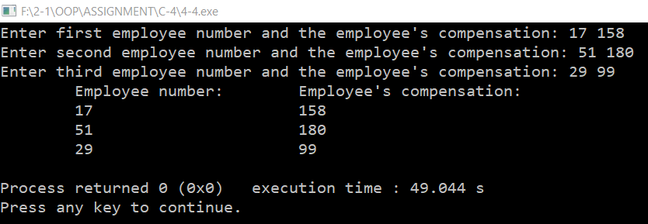

**Problem No.-06**

**Code:**

#include<iostream>

#include<iomanip>

using namespace std;

enum etype {laborer,secretary,manager,accountant,executive,researcher};

int main()

{

etype emp;

char type;

cout<<"Enter employee type (first letter only: laborer, secretary, manager,accountant, executive, researcher): ";

cin>>type;

switch(type)

{

case 'l':

emp=laborer;

break;

case 's':

emp=secretary;

break;

case 'm':

emp=manager;

break;

case 'a':

emp=accountant;

break;

case 'e':

emp=executive;

break;

case 'r':

emp=researcher;

break;

}

cout<<"Employee type is ";

switch(emp)

{

case laborer:

cout<<"laborer"<<endl;

break;

case secretary:

cout<<"secretary"<<endl;

break;

case manager:

cout<<"manager"<<endl;

break;

case accountant:

cout<<"accountant"<<endl;

break;

case executive:

cout<<"executive"<<endl;

break;

case researcher:

cout<<"researcher"<<endl;

break;

}

return 0;

}

**Output:**

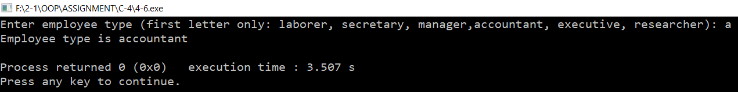

**Problem No.-08**

**Code:**

#include<iostream>

#include<iomanip>

using namespace std;

struct fraction

{

int numerator,denominator;

char ch;

};

int main()

{

fraction f1,f2;

cout<<"Enter first fraction: ";

cin>>f1.numerator>>f1.ch>>f1.denominator;

cout<<"Enter second fraction: ";

cin>>f2.numerator>>f2.ch>>f2.denominator;

cout<<"Addition: "<<f1.numerator*f2.denominator+f2.numerator*f1.denominator<<"/"<<f1.denominator*f1.denominator<<endl;

return 0;

}

**Output:**

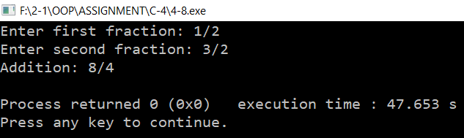

**Problem No.-10**

**Code:**

#include<iostream>

#include<iomanip>

using namespace std;

struct sterling

{

int pounds,shillings,pence;

};

int main()

{

double deci,deci1,deci2;

cout<<"Enter decimal pounds: ";

cin>>deci;

sterling New;

New.pounds=static_cast<int>(deci);

deci1=(deci-New.pounds)*20;

New.shillings=static_cast<int>(deci1);

deci2=(deci1-New.shillings)*12;

New.pence=static_cast<int>(deci2);

cout<<"Equivalent in old notation = \x9c"<<New.pounds<<"."<<New.shillings<<"."<<New.pence<<"."<<endl;

return 0;

}

**Output:**

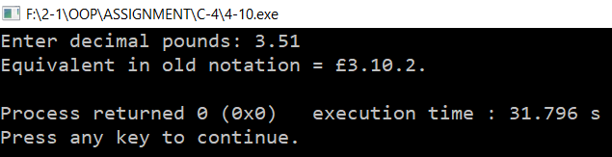

**Problem No.-12**

**Code:**

#include<iostream>

#include<iomanip>

using namespace std;

struct fraction

{

float numerator,denominator;

};

int main()

{

fraction f1,f2;

char t;

cout<<"Enter first fraction: ";

cin>>f1.numerator>>f1.denominator;

cout<<"Enter an operator(+, -, *, /): ";

cin>>t;

cout<<"Enter second fraction: ";

cin>>f2.numerator>>f2.denominator;

switch(t)

{

case '+':

cout<<"Addition: "<<f1.numerator<<"/"<<f1.denominator<<" + "<<f2.numerator<<"/"<<f2.denominator<<" = "<<((f1.numerator*f2.denominator+f1.denominator*f2.numerator)/(f1.denominator*f2.denominator))<<endl;

break;

case '-':

cout<<"Subtraction: "<<f1.numerator<<"/"<<f1.denominator<<" - "<<f2.numerator<<"/"<<f2.denominator<<" = "<<((f1.numerator*f2.denominator-f1.denominator*f2.numerator)/(f1.denominator*f2.denominator))<<endl;

break;

case '*':

cout<<"Multiplication: "<<f1.numerator<<"/"<<f1.denominator<<" * "<<f2.numerator<<"/"<<f2.denominator<<" = "<<((f1.numerator*f2.numerator)/(f1.denominator*f2.denominator))<<endl;

break;

case '/':

cout<<"Division: "<<f1.numerator<<"/"<<f1.denominator<<" / "<<f2.numerator<<"/"<<f2.denominator<<" = "<<((f1.numerator*f2.denominator)/(f1.denominator*f2.numerator))<<endl;

break;

}

return 0;

}

**Output:**

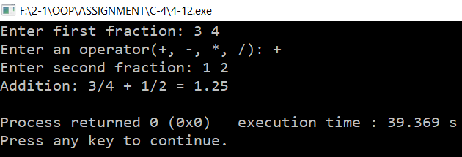

**Chapter-05**

**Problem No.-02**

**Code:**

#include <iostream>

using namespace std;

double power(double n, int p=2);

int main()

{

double n,ans;

int p;

char t;

cout<<"Enter number: ";

cin>>n;

cout<<"Want to enter a power (y/n)? ";

cin>>t;

if(t=='y')

{

cout<<"Enter power: ";

cin>>p;

ans=power(n,p);

}

else

ans=power(n);

cout<<"Answer is "<<ans<<endl;

return 0;

}

double power(double n,int p)

{

double result=1;

for(int j=0; j<p; j++)

result*=n;

return result;

}

**Output:**

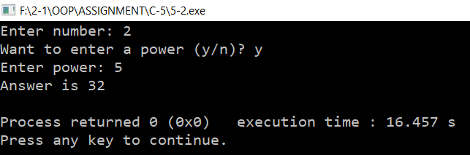

**Problem No.-04**

**Code:**

#include<iostream>

#include<iomanip>

using namespace std;

struct Distance

{

int feet;

float inches;

};

Distance fun(Distance d1, Distance d2);

void display(Distance dx);

int main()

{

Distance dis1,dis2,dis3;

cout<<"Enter first distance in feet and inches: ";

cin>>dis1.feet>>dis1.inches;

cout<<"Enter second distance in feet and inches: ";

cin>>dis2.feet>>dis2.inches;

dis3=fun(dis1,dis2);

display(dis3);

return 0;

}

Distance fun(Distance d1,Distance d2)

{

if(d1.feet>d2.feet) return d1;

if(d1.feet<d2.feet) return d2;

if(d1.inches>d2.inches) return d1;

else

return d2;

}

void display(Distance dx)

{

cout<<"Larger distance is: "<<dx.feet<<"\'-"<<dx.inches<<"\""<<endl;

}

**Output:**

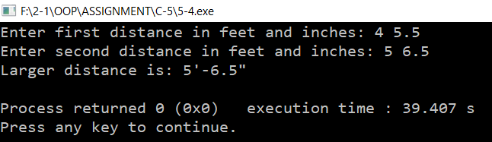

**Problem No.-06**

**Code:**

#include<iostream>

using namespace std;

struct time

{

int hours;

int minutes;

int seconds;

};

long long int time_to_secs(time ta);

time secs_to_time(long long int tb);

void display_t(time tx);

int main()

{

time t1,t2;

long long int time;

cout<<"Enter hours: ";

cin>>t1.hours;

cout<<"Enter minutes: ";

cin>>t1.minutes;

cout<<"Enter seconds: ";

cin>>t1.seconds;

cout<<"Total time structure in seconds is: "<<time_to_secs(t1)<<endl;

cout<<"Enter total time in seconds: "; cin>>time;

t2=secs_to_time(time);

cout<<"Total seconds in time structure is: ";

display_t(t2);

return 0;

}

long long int time_to_secs(time ta)

{

return ta.hours*3600+ta.minutes*60+ta.seconds;

}

time secs_to_time(long long int tb)

{

time tt;

tt.hours=(tb/60)/60;

tt.minutes=(tb/60)%60;

tt.seconds=tb%60;

return tt;

}

void display_t(time tx)

{

cout<<tx.hours<<":"<<tx.minutes<<":"<<tx.seconds<<endl;

}

**Output:**

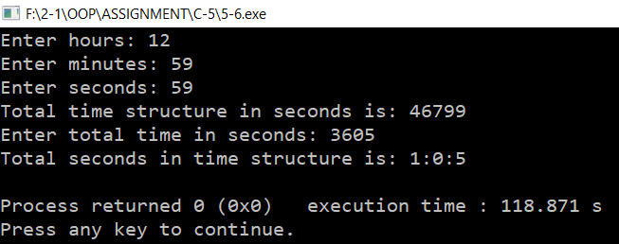

**Problem No.-08**

**Code:**

#include<iostream>

using namespace std;

void Swapn(int a,int b);

void displays(int x,int y);

int main()

{

int p,q,x;

cout<<"Enter two numbers: ";

cin>>p>>q;

Swapn(p,q);

return 0;

}

void Swapn(int a, int b)

{

int temp;

temp=a;

a=b;

b=temp;

displays(a,b);

}

void displays(int x,int y)

{

cout<<"After swapping: "<<x<<" "<<y;

}

**Output:**

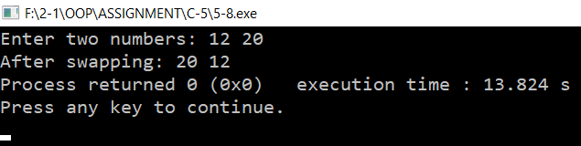

**Problem No.-10**

**Code:**

#include<iostream>

#include<iomanip>

using namespace std;

int count=0;

void global();

int localstat();

int main()

{

int s;

global(); global();

global(); global();

global(); global();

global(); global();

global(); global();

localstat();

localstat();

localstat();

localstat();

s=localstat();

cout<<"I have been called "<<count<<" times using global variable"<<endl;

cout<<"I have been called "<<s<<" times using local static variable"<<endl;

return 0;

}

void global()

{

count++;

}

int localstat()

{

static int cnt=0;

cnt++;

return cnt;

}

**Output:**

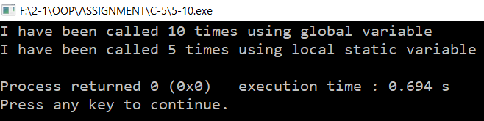

**Problem No.-12**

**Code:**

#include<iostream>

#include<iomanip>

using namespace std;

struct fraction

{

float numerator, denominator;

};

fraction fadd(fraction a1, fraction b1);

fraction fsub(fraction a2, fraction b2);

fraction fmul(fraction a3, fraction b3);

fraction fdiv(fraction a4, fraction b4);

void Display(fraction x);

int main()

{

fraction f1,f2,add,sub,mul,div; char t;

cout<<"Enter first fraction: "; cin>>f1.numerator>>f1.denominator;

cout<<"Enter an operator(+, -, *, /): "; cin>>t;

cout<<"Enter second fraction: "; cin>>f2.numerator>>f2.denominator;

switch(t)

{

case '+':

add=fadd(f1,f2);

cout<<"Addition: "<<f1.numerator<<"/"<<f1.denominator<<" + "<<f2.numerator<<"/"<<f2.denominator<<" = ";

Display(add);

break;

case '-':

sub=fsub(f1,f2);

cout<<"Subtraction: "<<f1.numerator<<"/"<<f1.denominator<<" - "<<f2.numerator<<"/"<<f2.denominator<<" = ";

Display(sub);

break;

case '*':

mul=fmul(f1,f2);

cout<<"Multiplication: "<<f1.numerator<<"/"<<f1.denominator<<" * "<<f2.numerator<<"/"<<f2.denominator<<" = ";

Display(mul);

break;

case '/':

div=fdiv(f1,f2);

cout<<"Division: "<<f1.numerator<<"/"<<f1.denominator<<" / "<<f2.numerator<<"/"<<f2.denominator<<" = ";

Display(div);

break;

}

cout <<endl;

return 0;

}

fraction fadd(fraction a1,fraction b1)

{

fraction add1;

add1.numerator=a1.numerator*b1.denominator+a1.denominator*b1.numerator;

add1.denominator=a1.denominator*b1.denominator;

return add1;

}

fraction fsub(fraction a2,fraction b2)

{

fraction sub1;

sub1.numerator=a2.numerator*b2.denominator-a2.denominator*b2.numerator;

sub1.denominator=a2.denominator*b2.denominator;

return sub1;

}

fraction fmul(fraction a3,fraction b3)

{

fraction mul1;

mul1.numerator=a3.numerator*b3.numerator;

mul1.denominator=a3.denominator*b3.denominator;

return mul1;

}

fraction fdiv(fraction a4,fraction b4)

{

fraction div1;

div1.numerator=a4.numerator*b4.denominator;

div1.denominator=a4.denominator*b4.numerator;

return div1;

}

void Display(fraction x)

{

cout<<x.numerator/x.denominator<<endl;

}

**Output:**

